AI for Detecting Hidden Cyberthreats in Encrypted Data

Final Year Project Report

Obaid Sheikh Ahmed (BAI-21F-012)
Arsalan (BAI-21F-003)
Mohammad Talha Panhwar (BAI-21F-008)
SESSION 2021-2025



Supervisor

Professor Azeem Inam

Project report in partial fulfillment of the requirements for the award of Bachelors of Science (Artificial Intelligence) degree.
IN
DEPARTMENT OF ARTIFICIAL INTELLIGENCE
SINDH MADARESSATUL ISLAM UNIVERSITY KARACHI, PAKISTAN
(JULY 2024)

DECLARATION

We hereby declare that this project report is based on our original work except for citation and quotation which have been duly acknowledged. We also declare that it has not been previously and concurrently submitted for any other degree or award at SINDH MADARESSATUL ISLAM UNIVERSITY or other institute.

1) Name: Obaid Sheikh Ahmed (BAI-21F-012)

Signatures: _________________

2) Name: Arsalan (BAI-21F-003)

Signatures: _________________

3) Name: Muhammad Talha Panhwar (BAI-21F-008)

Signatures: ________________

AI for Detecting Hidden Cyberthreats in Encrypted Data

APPROVAL FOR SUBMISSION

THE DEPARTMENT OF ARTIFICIAL INTELLIGENCE, SINDH MADRESSATUL ISLAM UNIVERSITY, ACCEPTS THIS THESIS SUBMITTED BY Obaid Sheikh Ahmed, Arsalan and Muhammad Talha Pnahwar IN ITS PRESENT FORM AND IT IS SATISFYING THE DISSERTATION REQUIREMENTS FOR THE AWARD OF BACHELOR DEGREE IN COMPUTER SCIENCE.
SUPERVISOR:
Professor Azeem Inam

Designation ________________________

HOD OF DEPARTMENT:
DR. MANSOOR KHURO ________________________

DEAN/HOD OF DEPARTMENT:
DR. AFTAB AHMED SHAIKH ________________________

DATED: _______

DEPARTMENT OF SOFTWARE ENGINEERING

SINDH MADRESSATUL ISLAM UNIVERSITY,

KARACHI, PAKISTAN

ABSTRACT
The use of encrypted network traffic is rapidly increasing day by day. This creates challenges for traditional Intrusion Detection Systems (IDS) because they faces lot of difficulties in facing the analyzation of encrypted flows. This study has addressed this issue by developing an AI based system which can detect hidden cyber threats from the traffic flows. The importance of this research is to ensure data security and to ensure the user privacy and provide scalable solutions for modern digital environments like Iot, cloud and enterprise network. Two datasets used in this study, CICID 2017 and UNSW-NB15. These datasets contain multiple attacks and flow level features. Traditional Machine Learning and deep learning models applied on both datasets. A hybrid model is proposed which use autoencoder to learn the traffic patterns of the data and XGBoost classifier, which performed best on CICID 2017 dataset, is used to predict attacks. Result shows that XGBoost performed best on CICID 2017 dataset achieving the accuracy of 98.62% and Random Forest classifier performed best on UNSW-NB15 dataset achieving the accuracy of 99.23%. Hybrid model gave results better than the traditional models applied on CICID2017 dataset. For future implementation this AI model is deployed on cloud hosted platform, which provide detection from the rest API and real time monitoring from website.

The copyright of this report belongs to the author under the term of copyright ordinance 1962 as qualified by Intellectual property policy of SMIU University. Due acknowledgement shall always be made of the use of any material contained in, or driver from this report.
© 2023, Names of Members, all rights reserved.

ACKNOWLEDGEMENT

In the name of Allah, the most Gracious and the Most Merciful.
Peace and blessing of Allah be upon Prophet Muhammad ﷺ

Firstly, we would like to thanks Allah SWT for blessing us with the hope of this new idea and then We would like to express our deepest gratitude and appreciation to Sir Azeem Inam, our dedicated and supportive course supervisor, for his invaluable guidance and unwavering encouragement throughout the completion of our Final Year Project (FYP). His expertise, insightful feedback, and commitment to our academic growth have been instrumental in shaping the outcome of this project.

_______________ meticulous attention to detail and his ability to provide constructive criticism helped refine our research methodology, strengthen our analytical approach, and enhance the overall quality of this documentation. His patience, accessibility, and willingness to invest time and effort in addressing our queries and concerns played a significant role in our collective personal and professional development.

Furthermore, we are deeply grateful to our families and friends for their unwavering support, understanding, and encouragement throughout this challenging endeavor. Their belief in our abilities and their constant motivation have been a constant source of inspiration.

This project would not have been possible without the collective efforts and support of these individuals and many others who have contributed to our academic and personal growth. We are truly honored and humbled by their presence in our journey.

Lastly, we would like to express our heartfelt appreciation to all the participants who willingly participated in the data collection process, enabling us to gather valuable insights and conduct a comprehensive analysis.

DEDICATION

TABLE OF CONTENTS
Declaration -------------------------------------------------------------------------------------------------- 2
Approval ----------------------------------------------------------------------------------------------------- 3
Abstraction --------------------------------------------------------------------------------------------------- 4
Acknowledgements ----------------------------------------------------------------------------------------- 5
Dedication ---------------------------------------------------------------------------------------------------- 6
CHAPTER 1
INTRODUCTION
  - Historical Background
  - Keywords Explanation
    - Artificial Intelligence
    - Cyber Threats
    - Encrypted Data
    - Hidden Threats
  - Objectives of the present study
  - Novelty of the Study
  - Problem Statement
  - Scope
  - Team Organization
  - Feasibility Study
    - Risks Involved
    - Resource Requirement
  - Organization of the Report

CHAPTER 2
LITERATURE REVIEW

  - Cross Dataset Generalization Gap
    - How this study fills the gap:
  - Privacy Respecting Detection in Encrypted Traffic
    - How this study fills the gap:
  - Vast amount of work in same way in same study:
    - How this study fills the gap:

CHAPTER 3
DATASETS
  - DATASET DESCRIPTION
    - CICID2017
    - UNSW-NB15
  - Necessary Details of recent study that utilize these datasets for there studies

CHAPTER 4

METHODOLOGY
4.1 Dataset Merging
4.1.1 CICID2017 Dataset
4.1.2 UNSW-NB15 Dataset
4.2 Data Analysis
4.2.1 Data Analysis of CICID2017
4.3 Preprocessing
4.3.1 Preprocessing of CICID2017 Dataset
4.3.2 Data Analysis of CICID2017 Dataset

4.2 Preprocessing of CICD2017
    - Class Diagram
  - Logical Design
    - ER Diagram
    - Data Flow Diagram
  - Physical Design
  - Interfaces/GUI
4.5 Project Plan & Execution ---------------------------------------------------------------------------- 34
4.6 Gantt Chart Representation ------------------------------------------------------------------------ 35

CHAPTER 5
RESULTS
5.1. Algorithm(s)
  - Tools/Technologies Used
  - Methodology

CHAPTER 6
DISCUSSION
6.1. Testing----------------------------------------------------------------------------------------32
6.1.1. Test Scope---------------------------------------------------------------------------------33
6.1.2. Levels of Testing (Unit, Integration, System)-------------------------------------------------------------------------------33
6.1.3. Methods of Testing (Blackbox, Whitebox, Grebox) -----------------------------------------------------------------------34
6.1.4. Types of Testing-------------------------------------------------------------------35
6.2. Testing Tools (if any) --------------------------------------------------------------35
6.2. Test-cases --------------------------------------------------------------35
6.3. Evaluation-------------------------------------------------------------------------------

CHAPTER 7
CONCLUSION
7.1. Conclusion --------------------------------------------------------------------------------
7.2. Review of the project and the reiteration of important findings ----------------
7.3 Suggestion of future work ----------------------------------------------------------------

REFERENCES --------------------------------------------------------------------------------

Chapter 1
Introduction
1.1 Historical background:
Cyber Security becomes the important part of life form the day internet was introduced to people. Protecting someone’s private and sensitive data is important as digital systems taking place over global operations. E.g: Protecting online data of every individual, financial transaction, national defence networks and healthcare records. Over the time the security of stuff available on internet is enhancing day by day which includes firewalls along with software of antivirus and Intrusion Detection Systems (IDS). The working of all these techniques is to block the known threats effectively. Whereas technology is increasing so as the cyber attacks increasing its intensity on the sensitive data. Due to this, organizations have no choice but to work more and more on encryption techniques. Traditional security tools can’t scan encrypted traffic properly, so attackers started using these secure channels themselves hiding malicious payloads inside wrapped in layers of unreadable code ironically turning protection into vulnerability. Situations like these makes the cyber security team in more stress, leading them to work more on protection of data of any organization. As organizations faced many difficulties in protecting data why not make a smart security tool? In the field of Information Technology, Artificial Intelligence is a boost to any work which take human efforts and time. Security purpose works, if done with Artificial Intelligence, will makes work easy. Machine learning ML and Deep learning DL are leading the charge here with AI stuff. In sense of cyber security, ML and DL train the model of Ai application or software which can find out the malicious activities based on there training samples parameters and entries. The model after training see the real time patterns and detect the suspicious activity. For example: Timing, packet sizes, those statistical hiccups that don't add up normally. All while keeping the actual data locked tight. The technology is not perfect obviously. But being able to flag potential threats just by watching how data moves around changes things big time. Especially when you consider how much encrypted traffic we're dealing with daily now.
1.2 Keywords Explanation
1.2.1 Artificial Intelligence
The capability of a machine to do tasks same as human do, is . Some tasks requires human intelligence which can be done by machines and this is because of Artificial Intelligence. Artificial intelligence (AI) models are used in cybersecurity to identify patterns of existing threats, identify anomalies, and even forecast undiscovered or zero-day threats. AI has become a potential weapon for data protection against the cyber threats of modern days.
1.2.2 Cyber Threats
A malicious activity that threatens to damage or steal data from a system, is known as Cyber Treats, which consists Distributed Denial of Service (DDoS) attacks, phishing attacks, advanced persistent threats and ransomware. These attacks are dangerous for anyone’s systems and these threats becoming more stronger day by day making challenging task to security providers.
1.2.3 Encrypted Data
The human understandable data or any information that has been transformed to unreadable form to protect it from unauthorized access, is known as Encrypted data. Data integrity and confidentiality are therefore guaranteed. Some popular encryption standards are SSL/TLS, RSA, and AES. Although encryption shields information from unwanted access, it also prevents conventional security tools from scanning payloads for dangers.
1.2.4 Hidden Threats
Some of the threats that are purposefully hidden to avoid detection and appears suddenly, are known as Hidden Threats. Backdoors encoded in encrypted communication, malware command-and-control (C2) signals, and data exfiltration efforts are examples of hidden risks that might affect encrypted data. It is necessary to examine traffic flow, metadata, and behavioral irregularities in order to identify such threats without decrypting the content.
1.3 Objectives of the Present Study
The objectives of this study are, building a machine learning model using encrypted traffic datasets. They will test how accurate it is at catching sneaky threats without disturbing legitimate traffic. Then there's checking which one actually works best in real setups either it is from deep learning or from traditional machine learning approaches. Second objective of this study is to combine different techniques for better results. Like using an autoencoder for spotting weird patterns paired with XGBoost for classifying threats. Whole point is making something that's both efficient and reliable compared to existing tools out there and judging the performance of different models by standard stuff like accuracy, precision rates and recall percentages across different attack scenarios. Benchmarking against current methods comes next. After comparing the best performing model on the datasets, now comes a part to compare Hybrid model with the best performing traditional model to see if the hybrid model actually improves detection rates while keeping false alarms low. Third objective of this study is to deploy our model on virtual machine and show the results of the best performing model in website while using random data use for cyber threats, a system that works in real-world networks without slowing things down or requiring massive computing power compared to older detection systems.
1.4 Novelty of Study
Most intrusion detection setups right now depend on checking content directly but know that approach falls apart when dealing with encrypted data. This study aims to make an AI based system that detects cyber threats within the Encrypted Data. Traditional detection of threats usually decrypt the encrypted data to understand where the problem is but AI system made in this study will keeps user privacy safe while delivering quicker solutions that can handle real-world scale. The system in this study uses deep learning models for example CNNs and Transformers. These analyze patterns within encrypted traffic flows which are not common in regular security tools yet. This study is focused purely on traffic patterns instead of peeking at actual data payloads. The train models of Ai based system will detect the malicious activities from the new traffic from any server or a website. The benefit is that suspicious activities can be detect within the encrypted data without compromising privacy, which has been a sticking point for years now. Validation covered multiple attack types and network conditions showing consistent performance metrics. Data sources included real-world traffic samples to test the model's flexibility. Two datasets were selected in this study to train and test which model works well so the best performing model will be the key solution of AI system. Scalability improvements come naturally from processing patterns instead of content depth which could be huge for cloud environments handling insane traffic volumes daily. The usage of Deep Learning is because there were complex attack signatures that rule-based systems might miss especially in encrypted formats where payloads look random. Combine feature engineering tricks with the model and model training to detect new patterns and stay relevant as it faces new patterns over time. The benefit of this approach is that it will not replace the existing tools, but it will act as another layer of security where the traditional tools might detect any new pattern incorrectly. Mostly detection tools depend on checking the decrypted content and then find suspicious activity in the data, but that approach falls apart when dealing with encrypted data. This study aims to make an AI based System which detect hidden patterns from the data without decrypting it. It keeps users safe and delivers quick solutions that can be done on real world scenario.
1.5 Problem Statement
The usage of internet is increasing day by day and browsing websites increase the traffic on any website, Encrypted traffic keeps blowing up these days. Here's the thing though, most tools right now can't even peek into encrypted stuff without decrypting first. Which is a problem for two big reasons. It slows everything or else it needs a high computational system to perform it quickly because if the system on which an application or software is running, late work might be the positive point for hackers to perform their work quickly and run before the system responds. It straight up breaks privacy laws like GDPR or HIPAA. Hackers totally know this weakness too. They hide their attack in encrypted tunnels more than ever now. Current technology is missing something crucial. To solve this gap, it is important to make a system that can spot bad patterns without decrypting data. This study shows that AI is thrown at the problem but keeps things private. The system detects suspicious activity if any malicious things happens while leaving the actual data sealed up tight. People always want both security and privacy. This might pull off that balancing act for once.

Chapter 2
Literature Review
Network intrusion detection used to rely on signature based systems back in the day. Now it’s shifted more toward anomaly based frameworks that use stuff of machine learning and deep learning. Early methods depended heavily on predefined signatures. Those worked well for spotting threats they already knew about but couldn’t handle new attack vectors at all really. All those limitations ended up driving a move toward statistical anomaly detection instead of relying on old methods. Supervised learning approaches started gaining ground around that time, people noticed how useful Supervised learning approaches were becoming in machine learning algorithms. It really took off here stuff like decision trees SVM models k nearest neighbors all that became pretty common, main reason was their ability to take labeled examples and apply them more broadly, older systems couldn’t do that as effectively, so this made a big difference over time. People realized these methods could actually adapt better when faced with new types of attacks which was kind of a game changer even if it wasn’t perfect right away there were still challenges obviously but compared to signature based approaches this felt like progress finally happening after years of stagnation in the field. Deep learning taking things even further down that path today’s systems are way more flexible because of all that groundwork laid back then by those earlier machine learning techniques honestly without those steps forward we would probably still be stuck dealing with way more false positives and missed threats across networks globally. Some techniques like Random Forest and gradient-boosted models (like XGBoost and LightGBM) are machine learning-based approaches that have continuously produced great performance in intrusion detection applications in recent studies. Random Forest classifier and Extra Trees classifiers have showed great accuracy in a recent comparative analysis across the UNSW-NB15, CIC-IDS2017, and CIC-IDS2018 datasets, attaining 99.59% and 99.95% on UNSW-NB15, respectively, and even 99.99% on CIC-IDS2017 under ten-fold cross-validation [1]. Deep Learning which use in data like time-series and location data, now a days used in traffic data. A light model CNN_BiLSTM is used in a recent study, achieving the accuracy of 97.28% in detecting intrusion from normal traffic [2]. Similarly, another study showed that, when applied an attention-augmented LSTM architecture (AT-LSTM) on UNSW-NB15, it perform better than other models that was used in the study, achieving the accuracy of 92.2%. CNN-BiLSTM applied to UNSW-NB15 resulting in the result with the accuracy of 77% and Rule-Based system achieve accuracy of 57% [3]. Furthermore, another study uses the data of UNSW-NB15 and Network Security Laboratory Knowledge Discovery in Databases (NSL-KDD) and applied a Neural Network DNN model to get a 80-90% of accuracy. This study shows that if DNN is not applied carefully then there will be an risk of overfitting which results in weak performance [4].
In study of 2021, it is shown that when Network traffic data is converted in binary form using finite state machine technique, it improved the performance of LSTM and GRU models by 13-18% and F1 score of the dataset also improved [5]. There is still some gap in researches that is mostly studies show the testing on one dataset, due to which general use of traffic pattern isn’t clear. Pre-processing and Feature selection are always different in every study that makes it difficult to compare results. For example, a study in 2022 shows that changing features from 42 to 23 resulting in the improvement of MLP model by achieving accuracy of 84.2% from 82.3% but this method does not apply on other studies [6]. As mentioned above that mostly studies test there work on one dataset because each model perform differently on different datasets. In this study its also showed that the model trained on CICIDS2017 dataset, it results in good performance of model but the model applied to other datasets, it results bad. That’s why cross-dataset testing is important [7]. A recent study of 2024 shows that some models give high accuracy on training dataset but when those models test on other dataset, there accuracies fall down, proving that real-world reliability is often overestimated [8].
2.1 Cross Data Generalization
Many intrusion detection systems based on machine learning (ML-IDS) perform well when trained on the same dataset and tested on the same dataset, such as CIC-IDS-2017. Sometime their performance drops when they are applied to see new patterns(unseen dataset) like UNSW-NB15 or ISCX-12. For example, de Carvalho Bertoli et al. (2024) conducted a cross-dataset evaluation using multiple NetFlow-based datasets and observed a decline of up to 30% in AUROC when models were tested on datasets different from those they were trained on. This shows overfitting creates issue and a lack of generalizability in current approaches[8].
2.1.1 How this study fills the gap
This study explicitly trains and evaluates models separately on the datasets of CICIDS2017 and UNSW-NB15 without merging them. By keeping the datasets independent, the study is able to demonstrate the generalizability of the hybrid model across different network environments. This method solve the dataset overfitting problem and poor generalization issues highlighted in previous research.
2.2 Privacy-Respecting Detection in Encrypted Traffic
Normally intrusion detection systems depends on deep packet inspection (DPI), which do not produce any significant or desired effect in encrypted environments and raises privacy concerns. Many solutions were taken to decrypt traffic for analysis, this violates the privacy laws and increases computational power. A survey was published in 2021, which showed the existing privacy-preserving techniques and concluded that there is a significant gap between academic proposals and practical, scalable solutions for detecting threats in encrypted traffic[9].
2.2.1 How this study fills the gap
This study uses only flow-based features such as duration, packet size and inter-arrival times to detect suspicious activities in encrypted traffic without checking payload entirely, this is how the system maintains user privacy and achieve high accuracy. The model is hybrid architecture, combines from a deep learning-based autoencoder for feature extraction with an XGBoost classifier for final prediction, this provides an efficient and privacy friendly solution for real time work.
2.3 Vast amount of work in same way in same study:
Most of the studies works on one dataset with single or multiple results, due to which it is a bit difficult to search which model is best performing and the comparison between them is difficult because each study have done there all works in there own way.
2.3.1 How this study fill the gap
This study focus on the training and testing of multiple traditional models on two datasets (CICIDS2017 and UNSW-NB15) and comparing the best performing model among both datasets so that it will be easy to understands and search for the best performing model for further working if anyone wants to take over.

CHAPTER 3
DATASETS
3.1 DATASET DESCRIPTION
The performance of the proposed artificial intelligence-based detection model for identifying hidden cyber threats in encrypted data was evaluated using two publicly available and highly reputable datasets (CICIDS 2017 and UNSW-NB15). The reason to select both datasets were because of there detailed information in it, varieties of attack types through which an AI model can have more values to learn resulting in better results. These datasets are good for testing and training of machine learning and deep learning models, particularly in contexts where payload inspection is either not feasible or violates data privacy principles.
3.1.1 CICID2017 DATASET
The Canadian Institute for Cybersecurity developed a dataset in 2017 which is known as CICID 2017. This dataset is made of real world network traffic values which include Bengin and Attack. This dataset contains variety of threats vectors such as Brute Force, DDoS, Botnet and attacks based on Web also known as web based attacks. Each flow record contains a detailed set of flow level features like flow duration, packet counts, mean packet length, and inter arrival times. These features are useful for analyzing the behavior of network without relying on packet payloads so that the dataset help model to learn in a way that the model don’t need to decrypt the system to check the attacks. This dataset is used in this study to train machine learning and deep learning models and test them and do compare which model is the best performing among all models on this dataset.
3.1.2 UNSW-NB15 DATASET
UNSW-NB15 dataset is the second dataset which is used in this study. This dataset is developed by Australian Centre for Cyber Security. This dataset was created in 2015. The reason to use this dataset is because it has variety of attacks that are used in training and testing models for AI, where need of decryption don’t take place and this dataset has a detailed coverage of modern cyber threats generated using the IXIA Perfect Storm tool. With 49 features per flow, such as duration, packet size, protocol type, and TCP flags, the dataset includes more than two million entries. It covers several different kinds of attacks, including worms, reconnaissance, fuzzers, and exploits. The dataset is appropriate for intrusion detection even in encrypted contexts because of these flow-level properties, which make it possible to learn traffic behavior patterns effectively without depending on payload inspection. The suggested deep learning model performance in SDN-based IoT network scenarios was assessed in this study using UNSW-NB15.
  - Necessary Details of recent study that utilize these datasets for their studies
- A recent study presented deep learning based intrusion detection system, the reason of that study was to present a securing environment for Iot and SDN, using CICIDS 2017 dataset. A Long Short Term Memory (LSTM) model was developed by researchers that efficiently analyzed flow based features without decryption, making suitable for encrypted traffic scenarios. Their system was strictly evaluated against various modern cyberattacks such as DDoS, Brute Force, and Botnet intrusions and achieve great accuracy of 99.9% and a minimal false positive rate. This study shows that temporal deep learning models like LSTM works strong on real time network. Additionally it shows that CICIDS2017 dataset is useful to train IDS training[10].
A a recent study conducted an evaluation of several RNN-based models—including LSTM, bidirectional LSTM (BiLSTM), GRU, and bidirectional GRU—for binary intrusion detection using the UNSW-NB15 dataset, addressing severe class imbalance by applying SMOTE oversampling. They trained and tested each model for classifying network flows as normal or attack and measured performance by observing accuracy, precision, recall, F1-score, and AUC. The outcomes of that study highlighted that the BiLSTM model achieve the best performance, reaching approximately 95.01 % accuracy and an AUC of 0.9953 after SMOTE application, thus demonstrating its superiority in detecting intrusions within IoT network traffic environments[11].
To better understand the distribution and behavior of the data used for model training and evaluation, flow-level features such as flow duration, packet size mean, total forward and backward packets, and flow inter-arrival times were analyzed. Boxplots and correlation heatmaps were used to illustrate these characteristics, emphasizing the notable statistical distinctions between malicious and normal flows. In the CICIDS 2017 dataset, for example, anomalous increases in flow byte rates and inter-arrival periods were powerful predictors of botnet and DDoS attacks. Similarly, backdoor and reconnaissance attacks were linked to irregularities in protocol distributions and flow lengths in the UNSW-NB15 dataset. Such feature behaviors served as input signals to the machine learning models developed in this study. In addition to offering a variety of attack scenarios, both databases enable the creation of models that protect privacy. Because the goal of this research is to analyze encrypted traffic without decrypting it, the use of statistical flow-based features is in line with ethical and regulatory data-handling guidelines like GDPR and HIPAA. Furthermore, the CICIDS 2017 and UNSW-NB15 datasets were individually preprocessed by merging their respective internal files from their original zip archives to form two complete, unified datasets. Without combining the two datasets, this method guarantees that the entire spectrum of attack types and typical traffic patterns from each dataset are successfully recorded, enabling the model to learn from more complex and extensive network scenarios. A recent study published in Scientific Reports which applied deep learning and XGBoost techniques on CICIDS-2017 and UNSW-NB15 datasets using flow-based features for intrusion detection. The model is useful for encrypted contexts like SDN and IoT because it reached over 99% accuracy. By doing away with the need for payload data, this method preserves privacy while preserving excellent detection performance. The model is useful for encrypted contexts like SDN and IoT because it reached over 99% accuracy. By doing away with the need for payload data, this method preserves privacy while preserving excellent detection performance[12].
Using both UNSW-NB15 and CICIDS 2017, this study guarantees a solid basis for assessing the model's performance in practical settings. These datasets are excellent options for creating and evaluating AI systems meant to identify covert cyberthreats because of their flow-based information, current attacks, and compatibility with encrypted settings.

Chapter 4
Methodology
The methodology of this research focuses on preparing a robust and structured dataset for training machine learning models capable of detecting hidden cyber threats in encrypted network traffic. This process involved several critical stages, beginning with the collection of 2 datasets namely CICIDS2017 and UNSW-NB15, merging them, followed by intensive preprocessing, cleaning, and feature selection. To initiate the process, the CICIDS2017 and UNSW-NB15 datasets were selected due to there richness and diversity in representing real-world network traffic and cyberattacks.
  - Dataset Merging
4.1.1 Merging CICID2017 Dataset
The original structure of the CICIDS2017 dataset was distributed across several CSV files, each corresponding to different days and types of attacks such as DDoS, Port Scan, Web Attacks, and Infiltration attempts. These files included "Friday-Working Hours-Afternoon-DDos.pcap\_ISCX.csv," "Friday-Working Hours-Afternoon-PortScan.pcap\_ISCX.csv," "Friday-WorkingHours-Morning.pcap\_ISCX.csv," "Monday-Working Hours.pcap\_ISCX.csv," "Thursday-WorkingHours-Afternoon-Infilteration.pcap\_ISCX.csv," "Thursday-Working Hours-Morning-WebAttacks.pcap\_ISCX.csv," "Tuesday-Working Hours.pcap\_ISCX.csv," and "Wednesday-working Hours.pcap\_ISCX.csv." Each of these files was individually read using Python’s pandas library, and all were merged together to form a unified dataset. This merged dataset contained approximately 3,119,345 records with 85 columns, combining traffic from various attack vectors and benign communications into a single structured data file.
4.1.2 Merging UNSW-NB15 Dataset
Similarly the dataset of UNSW-NB15 is also divided into four separate parts: UNSW-NB15_1, UNSW-NB15_2, UNSW-NB15_3, and UNSW-NB15_4. To create a comprehensive and balanced dataset, all four parts were merged into a single unified file. Combining these segments ensured a diverse distribution of both normal and malicious traffic patterns, enhancing the robustness and generalizability of the machine learning models trained on it. This merged dataset was then used for further preprocessing and analysis. Each dataset contains 700001 rows and 49 columns. The names of columns in each dataset is same with the same order with the same values in it. Combining all datasets together to make a merge dataset of UNSW-NB15.
4.2 Data Analysis
The process of inspecting the dataset then cleaning it, transforming it to a form to find useful information and draw conclusion and support decision making is called Data Analysis. Getting something from raw data to useful information by applying logical and statistical techniques. Data Analysis helps identify the patterns and relationships that can lead to actionable insights and improved performance in various fields.

4.2.1 Data Analysis CICID2017
Once the datasets were successfully combined, the next stage involved the analysis of CICID dataset to analyze it so that later we compare the results of it’s visualization before and after preprocessing, analyzing CICIDs2017 main dataset.
In this study, data analysis was conducted to understand the patterns, trends, and relationships in the dataset. The dataset name is CICIDS 2017 dataset and is developed by the Canadian Institute for Cybersecurity. The primary objective of the analysis was to show how the data looks visually before the pre-processing of CICID dataset and how dataset look after it’s pre-processing. For analysis of main dataset it’s important that before applying any preprocessing techniques, an exploratory data analysis (EDA) was performed to gain initial insights, visualize data distributions, and identify potential issues such as missing or inconsistent values. In the analysis of main Dataset of CICID 2017, it includes several steps of code to perform. Python is selected to be the programming language to perform each step of programming including analyzing the dataset. The reason for selecting python programming language is that Python is easy to understand and write and execute. It is a vast language, basically the combination of factors that make it a versatile and accessible programming language. Python is use for various purposes like Web Development, Data Science and Machine Learning, Automation and scripting, Software Development, Scientific Computing and many more.
To start the work of Data Analysis, first thing to do is to import necessary libraries used for the work. After importing libraries, dataset is read to understand how to clean the dataset which best fits the AI model, enhancing it’s performance. Taking useful features by dropping unnecessary columns and selecting the useful columns. Then it is decided to plot three graphs to analyze the dataset’s result before and after it’s pre-processing, to observe the difference in dataset after the preprocessing. The first graph to make is a histogram. The result of histograms shows a detailed visual analysis of key numerical features which are extracted from network traffic data. These features are critical in understanding the behavior and structure of data flows within a network, and their distributions provide insight into typical patterns as well as potential anomalies, focuses on metrics such as flow duration, packet counts in both forward and backward directions, length statistics, flow rates, and inter-arrival times and various statistics related to forward packet lengths. These visualizations is the first step to understand network traffic.
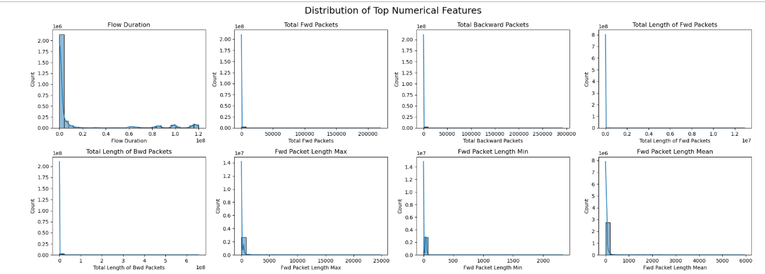
The histograms reveal that the majority of data points for each feature are concentrated at the lower end of the value spectrum. This suggests that most network flows are short-lived and consist of relatively few packets, both in the forward and backward directions. The data of packet length (maximum, minimum, average) skew towards the smaller values, which shows that typical packets are small, but some outliers such as big packets are also shown in the graph. These big packets might be unusual such as suspicious activity or network behaviour.
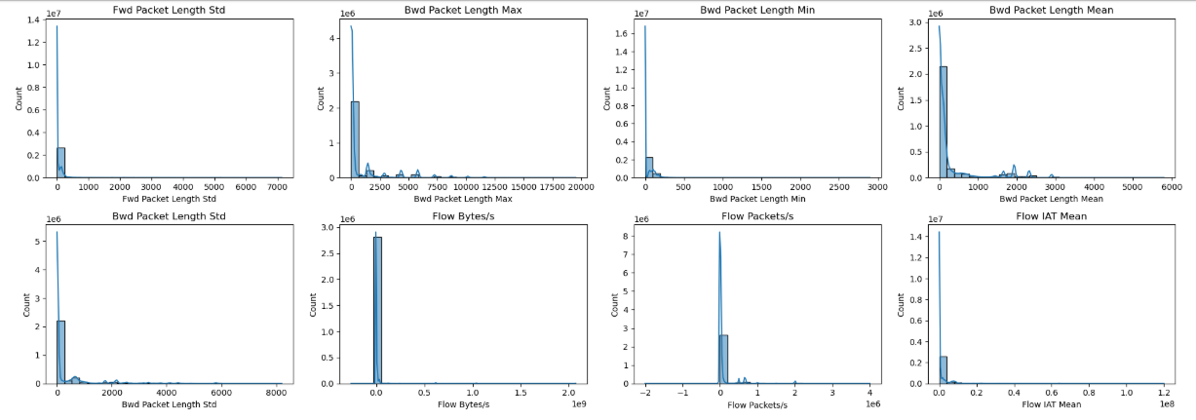
This analysis explore more packet level and flow level metrics. The standard deviation of forward and backward packet lengths, as well as their respective maximum, minimum, and mean values, again show a strong skew toward lower values. This supports the finding that, although there are occasional exceptions, most packets are small and uniform in size. For evaluating the throughput and timing properties of network traffic, the flow-level metrics—bytes per second, packets per second, and mean inter-arrival time—are very helpful. Additionally, their distributions show scarce occurrences of high-rate flows and a strong concentration at lower rates. These kinds of patterns are common in real-world network settings, where high-volume transfers can occasionally happen but the majority of traffic is modest and sporadic.
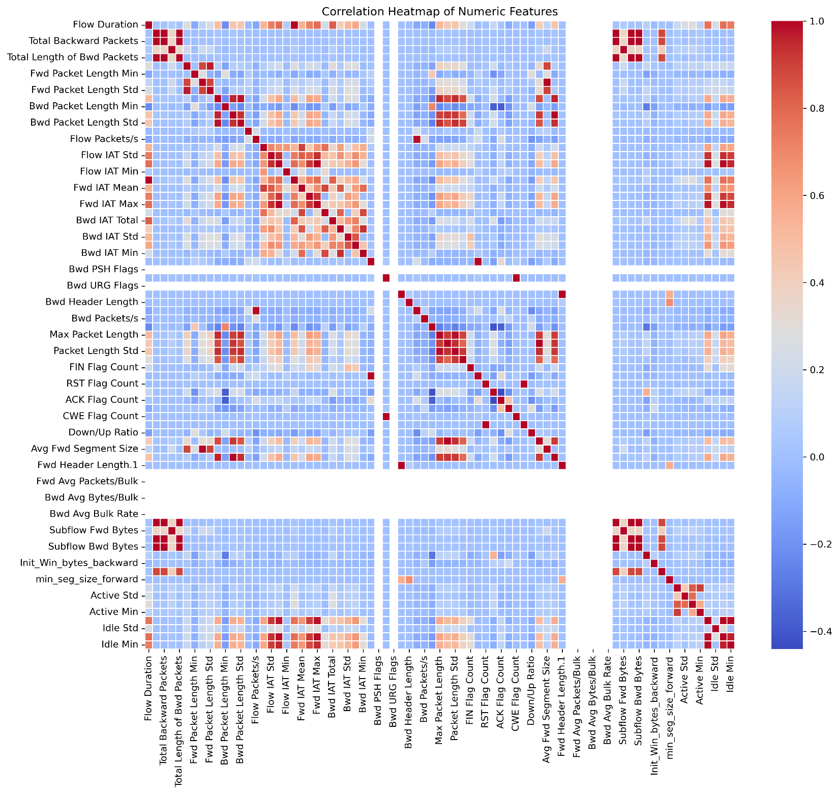
The correlation heatmap shows the relationship between different features of network. If packet size and duration follow similar trend then heatmap shows the strong relationship and the colour become dark there, if the relationship is weak then the colour is light. Researcher use this visualizations to understand the dependencies of variables with each other and there independencies. This is the easy way to visualize and understand the data. The heatmap is structured as a square matrix, with identical variables listed along both the x-axis and y-axis. Each cell within the matrix corresponds to a pairwise correlation coefficient, ranging from -1.0 to 1.0, and is color-coded to reflect the strength and direction of the relationship. A colour gradient is used, with white denoting little to no connection, blue denoting significant negative correlation, and red denoting high positive correlation. The diagonal line of red cells near the center of the heatmap shows how well each variable correlates with itself. This characteristic is common in correlation matrices and provides a visual reference point for understanding the remaining data. Because they show how several variables are related to one another, the off-diagonal cells are very interesting. For example, the heatmap indicates a high positive connection between "Fwd Packet Length Min" and "Fwd Packet Length Std," indicating that the standard deviation of a forward packet tends to grow as its minimum length does. This would suggest that within some kinds of network flows, packet sizes vary consistently. As would be predicted given their mathematical relationship, variables like "Packet Length Std" and "Packet Length Variance" likewise show a substantial positive association. However, the heatmap also shows negative connections, as the one between "Flow Packets/s" and "Flow Duration." According to this inverse connection, lengthier flows typically have lower packet rates, which might be a sign of sessions with little activity or idleness. These kinds of insights are useful for differentiating between bursty traffic and streaming traffic, for example. Furthermore, the heatmap's blue cells indicate regions where variables move in opposing directions, which is useful for spotting repetitive features or anomalies. The heatmap has many different variables, from flow-level features like "Subflow Fwd Bytes" and "Init_Win_bytes_backward" to packet-level metrics like "Bwd Packet Length Min" and "Fwd IAT Std." Along with flags and header-related characteristics, it includes "Bwd PSH Flags" and "Bwd Header Length," which are crucial for intrusion detection and protocol analysis. A comprehensive picture of network traffic patterns is provided by the addition of inter-arrival periods and bulk transfer measures, which further enhance the dataset. There are several uses for the correlation heatmap from an analytical perspective. In predictive models, it helps select features by detecting strongly correlated variables that can be redundant or cause multicollinearity. Additionally, it facilitates dimensionality reduction methods by identifying clusters of similar characteristics, such as Principal Component Analysis (PCA). A deeper comprehension of the data's underlying structure is also made possible by the heatmap, which is essential for creating reliable machine learning models and carrying out efficient network performance evaluations.

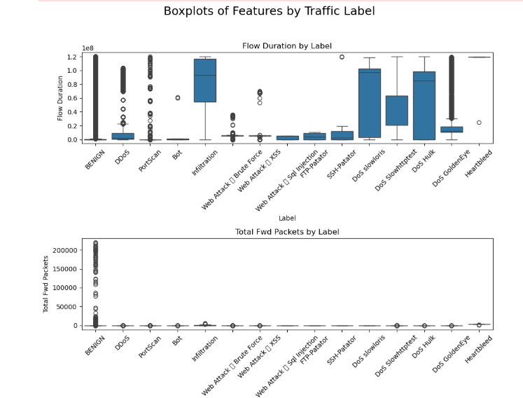
The first figure shows the distributions of Flow Duration and Total Forward Packets by label. The BENIGN and Infiltration labels exhibit a very wide range for Flow Duration, with many outliers, indicating a high variance in how long these traffic flows last. Conversely, other labels like PortScan and DDoS have very short flow durations. The Heartbleed attack traffic also shows a very long flow duration, similar to Infiltration. For Total Forward Packets, BENIGN traffic shows a wide range and many outliers, suggesting a high variability in packet counts. Other attack types, like DDoS and PortScan, have a much lower number of forward packets.
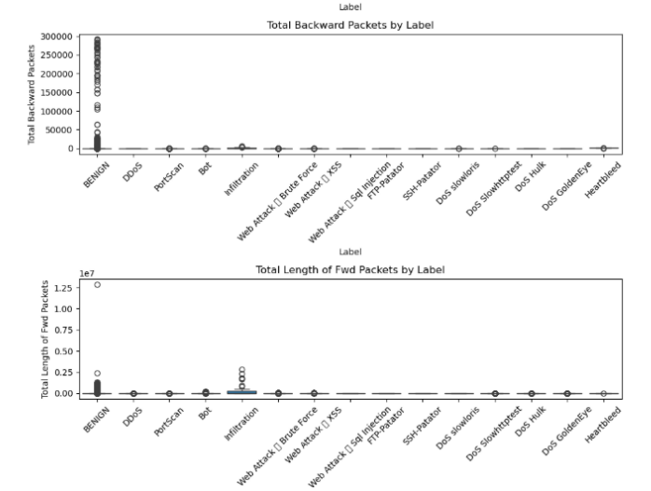
The distributions of the total length of forward packets and the total number of backward packets are shown in the second figure. Similar to the previous plot, BENIGN traffic has the widest distribution and the highest number of outliers for Total Backward Packets, indicating that legitimate traffic has a highly variable number of packets traveling from the destination back to the source. Most attack types, except for Infiltration, have a very low number of backward packets. The Infiltration label shows a slightly higher count of backward packets, which is expected as this type of attack often involves data exfiltration, resulting in some backward traffic. The plot for Total Length of Forward Packets shows that BENIGN and Infiltration traffic have the largest distributions, with many outliers, indicating large amounts of data being sent. Most other attacks show very small packet lengths, with the exception of some outliers for DDoS and PortScan.
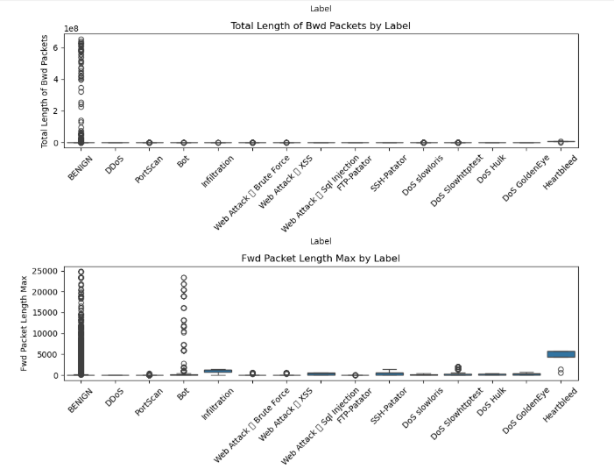
The third figure presents the distributions of Total Length of Backward Packets and Fwd Packet Length Max. Again, the BENIGN label has a high variance for Total Length of Backward Packets, with many outliers, indicating that legitimate traffic can have a large total length of backward packets. Most attack types have a total length close to zero. The Fwd Packet Length Max plot reveals that BENIGN, PortScan, and Heartbleed traffic have the highest maximum forward packet lengths, with Heartbleed showing a particularly high maximum length, which is characteristic of the large, malformed TLS packets used in the Heartbleed attack.
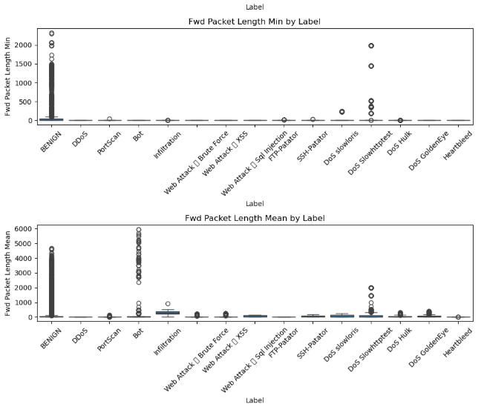
The final figure illustrates the distributions of the minimum and mean forward packet lengths. The Fwd Packet Length Min plot shows that the minimum packet length is very low for most traffic types, suggesting that a majority of traffic, both benign and malicious, includes small packets. However, the Fwd Packet Length Mean plot shows a clearer distinction. The BENIGN label has a relatively wide distribution, with a mean packet length ranging from small to moderate. In contrast, labels such as DDoS, Infiltration, and the various DoS attacks have a more constrained and typically lower mean packet length, which can be a key feature for identifying these types of attacks. The Heartbleed label stands out with a very high mean packet length, which again aligns with the nature of the attacks.

4.3 Preprocessing
4.3.1 Preprocessing of CICID2017 Dataset
Preprocessing the data to ensure its quality and suitability for model training. This began by importing necessary Python libraries, reading dataset then inspecting the merged dataset for null and infinite values. Null entries were identified using pandas’ null value detection capabilities, and subsequently, all rows containing nulls were dropped using the dropna() function to eliminate incomplete records. In order to prevent mistakes and inconsistencies throughout training, this step was crucial. Additionally, the dataset had a large number of infinite values that came from mathematical calculations made during the extraction of traffic features, especially in columns like "flow\_bytes/s" and "flow\_packets/s." These infinite values were handled by scanning for entries using NumPy’s infinity checks and applying a transformation to round all float values whether finite or infinite to a precision of five decimal places. In order to preserve consistency throughout the collection and standardize number representations, this rounding was essential.
After handling missing and infinite data, the dataset was reduced to only the most relevant features for the classification task. Based on their importance in describing flow-based network characteristics which are particularly crucial in encrypted situations where payload inspection is not feasible a collection of sixteen attributes was chosen. Metrics including flow duration, the total number of packets sent and received, byte rates, packet lengths, inter-arrival periods, TCP flag counts, and behavioral data like active mean duration were among these characteristics. Additionally, the 'label' column was kept as it provided information on whether a certain flow was benign or linked to a particular kind of attack. During model training, this column was the target variable. After the preparation stages were finished, the cleaned and improved dataset was stored in CSV format. This file was used as the last input for the modeling and assessment stages after the pre-processed data was visualized.
4.3.2 Data Analysis of CICID2017 Dataset
After the preprocessing of dataset it’s time to analyze it to see how the dataset looks visually. First visualization to perform is histogram.
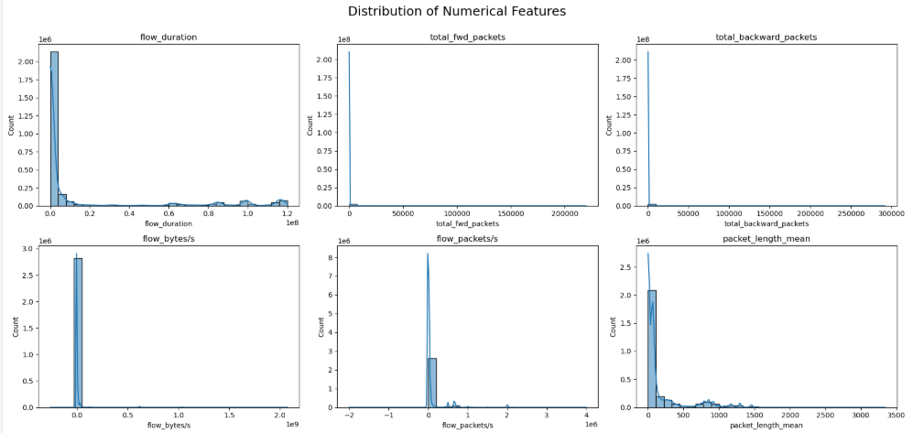
Across the histograms, a repeating pattern of skewed distributions is discernible. Most features, such as flow_duration, total_fwd_packets, total_backward_packets, flow_bytes/s, and packet_length_mean, are heavily skewed to the right. This indicates that the majority of data points have values close to zero, with a long tail extending to the right, representing a smaller number of instances with very high values. Network traffic data frequently exhibits this kind of distribution, with the majority of flows being brief and containing few packets.
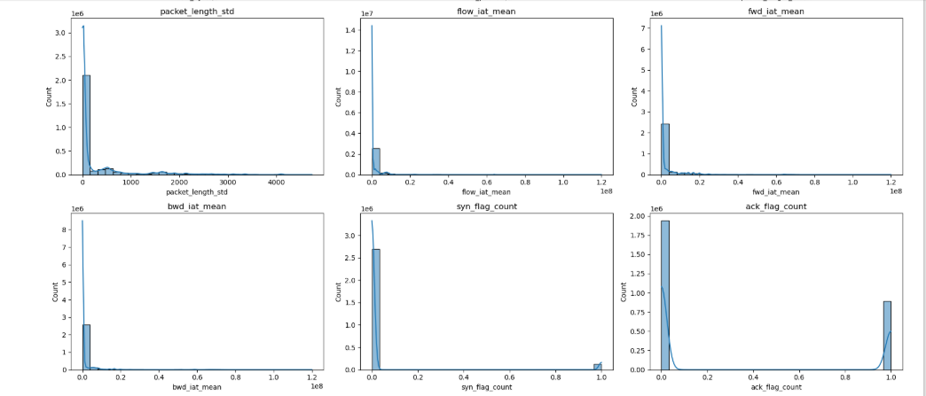
While a few flows are exceptionally long or contain a large number of packets. The features packet_length_std, flow_iat_mean, fwd_iat_mean, and bwd_iat_mean also exhibit this right-skewed behavior. On the other hand, certain traits exhibit discrete, non-continuous distributions. The majority of counts are grouped at zero, with a noticeable spike at one, according to the syn_flag_count and fin_flag_count histograms. Accordingly, these attributes are probably binary or indicate the frequency of a certain occurrence (for example, the presence of a SYN or FIN flag once in a flow). With a sizable portion of flows having an ack_flag_count of zero and another sizable group having an ack_flag_count larger than zero, ack_flag_count also exhibits a bimodal distribution, which may be an indication of the distinction between one-way and two-way communication.
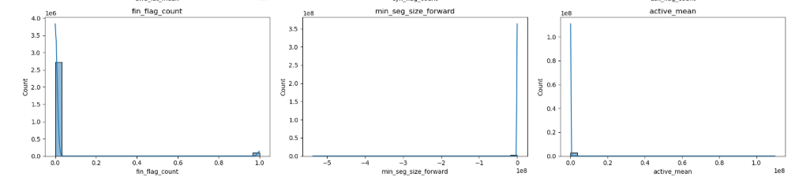
After pre-processing, some histograms, such min_seq_size_forward, seem to have a single, abrupt spike, suggesting that the data for that specific feature is not very variable. This suggests that nearly all data points for min_seq_size_forward have the same value, possibly zero, after some form of transformation or normalization. With the majority of values clustered close to zero, the characteristic active_mean also exhibits a severely skewed, nearly single distribution. Overall, the research shows that in order to manage the high skewness and broad range of values, which may otherwise impair the performance of machine learning models, careful feature scaling and transformation are required.
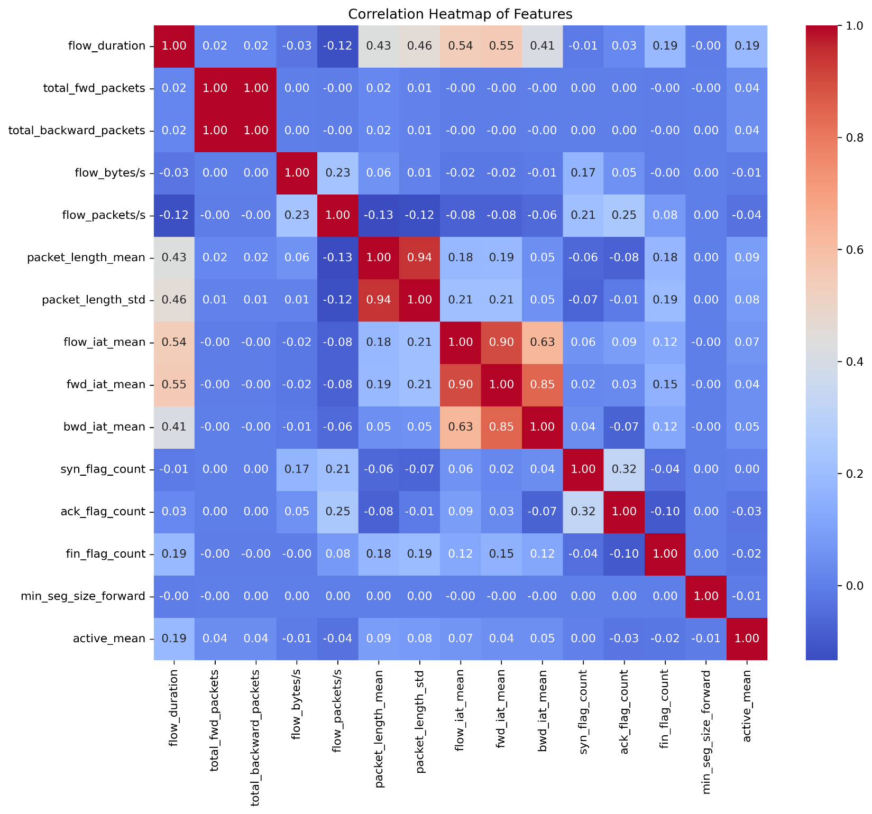
Now it’s time to plot a detailed correlation heatmap which meticulously displays the pairwise linear relationships between various numerical features of the dataset. A statistical metric that assesses the strength and direction of a linear relationship between two variables, the Pearson correlation coefficient is represented by each cell in this grid. Its value ranges from -1 to +1. A perfect positive correlation (+1.00) is represented by a deep red color bar, a perfect negative correlation (-1.00) by a deep blue color bar, and no linear correlation (0.00) by a white or light gray color bar on the right. The diagonal, from the top-left to the bottom-right, is filled with values of 1.00, as any feature is perfectly correlated with itself. A striking observation is the perfect positive correlation of 1.00 between total_fwd_packets and total_backward_packets, which strongly suggests that in this dataset, the number of packets sent in one direction is perfectly proportional to the number sent in the other. This indicates that these two features are essentially providing redundant information and one of them could be removed for model training to avoid the issue of multicollinearity. Similarly, the inter-arrival time metrics are highly correlated with each other; for example, flow_iat_mean shows a strong positive correlation of 0.90 with fwd_iat_mean and 0.85 with bwd_iat_mean, which is logical as these features all measure aspects of packet timing. A strong positive correlation of 0.94 is also evident between packet_length_mean and packet_length_std, implying that network flows with a larger average packet size also tend to have a wider variance in their packet lengths.
Significant but less severe correlations are also revealed by the heatmap. For example, flow_duration has a somewhat positive correlation with flow_iat_mean (0.54), fwd_iat_mean (0.55), and bwd_iat_mean (0.41), suggesting that longer flows often have bigger average inter-arrival periods between packets. The heatmap further shows that flow_bytes/s has very low correlations with most other features, suggesting it might capture unique information not present in the other variables. Knowing these linkages directly affects machine learning, therefore it's not simply an intellectual exercise. When choosing features, it is important to take large correlations into account because doing so may result in models that are unstable and difficult to understand. Therefore, this heatmap is a vital tool for the exploratory data analysis stage, helping to decide which variables to retain, modify, or exclude prior to training a predictive model.

A sequence of box plots that show the distribution of many numerical characteristics across various traffic labels—from normal ("BENIGN") to different kinds of attacks—are displayed in the visualization. After examining correlations, these plots are an essential step in comprehending how feature distributions differ by class, which is essential for creating a strong classification model. The median (the line within the box), the first and third quartiles (the box's sides), and the minimum and maximum values (the whiskers' ends) are the five essential statistics that each box plot uses to summarize the distribution of a feature. Potential outliers are shown by points that extend past the whiskers.
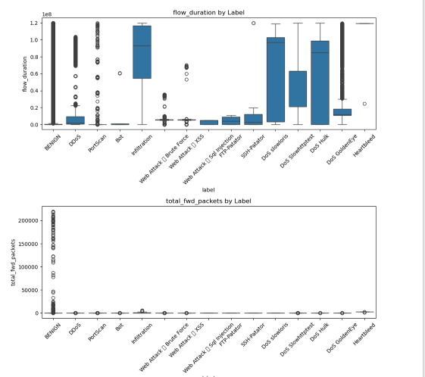
The box plots for flow_duration and total_fwd_packets show significant differences across labels. For flow_duration, benign traffic and some attack types like PortScan and DoS attacks exhibit a wide range of values, with some attack categories such as PortScan, Infiltration, and DoS slowloris showing a particularly high median duration. A large degree of diversity in flow durations is indicated by the existence of many outliers, particularly in benign traffic. Similarly, the total_fwd_packets and total_backward_packets box plots show that benign traffic has a very wide distribution, with a high concentration of flows having a small number of packets but a large number of outliers with very high packet counts. In contrast, many attack types, such as DDoS and PortScan, have a much tighter distribution for these features, with most flows containing a small number of packets and a low median value. This suggests that the total number of packets could be a distinguishing feature between benign and certain attack types.
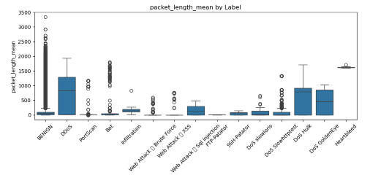
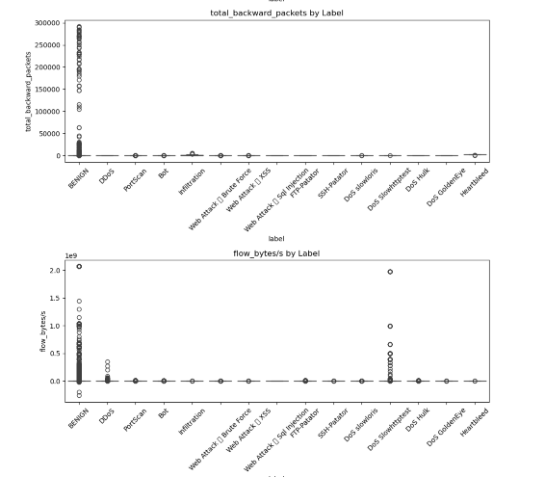

The box plots for flow_bytes/s and packet_length_mean also reveal interesting class-specific behaviors. The flow_bytes/s graphic reveals that although the median for the majority of labels is near zero, there are notable outliers that indicate flows with exceptionally high throughput, especially in benign traffic and some assaults. The packet_length_mean box plot shows a clear distinction, where certain attacks like DoS Hulk and DoS GoldenEye have a significantly higher median packet length compared to benign traffic and other attacks. This implies that a good way to spot these particular kinds of assaults could be to look at the average packet size.
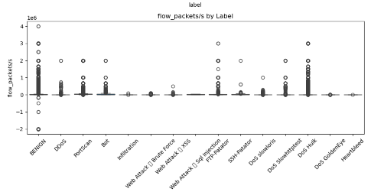
The "flow_packets/s by labels" box plot illustrates the distribution of the flow_packets/s feature, which represents the number of packets per second for a given network flow, across different traffic labels. The pace of packet transmission for benign traffic is efficiently contrasted with different attack types in this picture. The plot shows that for most labels, including benign traffic, the median value is very close to zero, suggesting that a significant portion of flows have a low packet rate. However, the presence of numerous outliers, particularly for benign traffic, indicates that while most benign flows have a low packet rate, a small number of them have exceptionally high rates. Conversely, most attack types, such as DDoS and PortScan, show a much tighter distribution with fewer high-value outliers, suggesting these attacks are characterized by a more consistent, and often low, packet per second rate. The potential of flow_packets/s as a differentiating characteristic for recognizing and categorizing various kinds of network traffic is demonstrated by its clear distributional pattern.
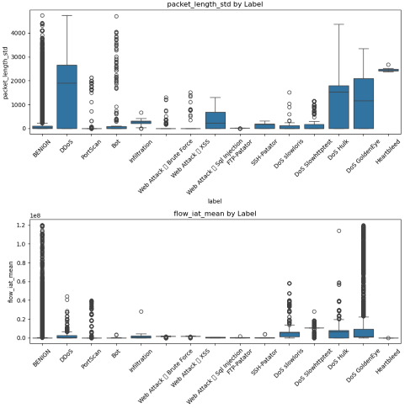
Furthermore, the box plots for packet_length_std and flow_iat_mean underscore the variability within and between classes. For packet_length_std, DoS attacks like DoS Hulk and DoS GoldenEye again show a higher median and a wider distribution, implying greater variance in packet sizes within these flows. For benign traffic, the flow_iat_mean figure has a relatively high median and broad dispersion; in contrast, many attack categories have significantly lower medians, which indicate quicker packet rates. Numerous outliers are present in all characteristics and labels, highlighting the necessity of treating these values robustly. These outliers may be a sign of various attack subtypes or typical but unexpected network activity. The distinct distributions observed for several features strongly suggest that these variables hold significant predictive power for classifying different types of network traffic and attacks.

